

***Data Structure and Algorithm (Lab)***

***Assignment - 1***

**Name:**

Ali Maqsood.

**Roll no:**

SU92-BSAIM-F23-050.

**Department:**

Software Engineering Department.

**Program:**

Artificial Intelligence.

**Section:**

BSAI-3A

**Task # 1:**

**Implement a stack using a class in Python. The stack should support the following operations:**

* push(element): Adds an element to the top of the stack.
* pop(): Removes and returns the top element from the stack.
* peek(): Returns the top element without removing it.
* is_empty(): Returns True if the stack is empty, False otherwise.
* size(): Returns the number of elements in the stack.

**Code:**

class stack():

    def __init__(self):

        self.stack=[]

    def push(self):

        value=input("Enter the element you want to Push: ")

        self.stack.append(value)

    def pop(self):

        print("Popped element is: ",self.stack.pop())

        print(f"The Top element is: {self.stack[-1]}")

    def peek(self):

        print(f"The Top element is: {self.stack[-1]}")

    def is_empty(self):

        if not self.stack:

            print("True.")

        else:

            print("False.")

    def size(self):

        print(f"The size of stack is: {len(self.stack)}.")

obj1=stack()

obj1.push()

obj1.push()

obj1.push()

obj1.pop()

obj1.peek()

obj1.size()

obj1.is_empty()

**Output:**

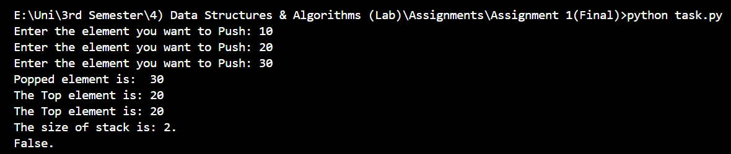

**Task # 2:**

**Implement a queue using a class in Python. The queue should support the following operations:**

* enqueue(element): Adds an element to the end of the queue.
* dequeue(): Removes and returns the front element from the queue.
* front(): Returns the front element without removing it.
* is_empty(): Returns True if the queue is empty, False otherwise.
* size(): Returns the number of elements in the queue.

**Code:**

class queue():

    def __init__(self):

        self.queue=[]

    def enqueue(self):

        value=input("Enter the element you want to Enqueue: ")

        self.queue.append(value)

    def dequeue(self):

        print("Dequeued element is: ",self.queue.pop(0))

        print(f"The Front element is: {self.queue[0]}")

    def front(self):

        print(f"The Front element is: {self.queue[0]}")

    def is_empty(self):

        if not self.queue:

            print("True.")

        else:

            print("False.")

    def size(self):

        print(f"The size of queue is: {len(self.queue)}.")

obj2=queue()

obj2.enqueue()

obj2.enqueue()

obj2.enqueue()

obj2.dequeue()

obj2.front()

obj2.size()

obj2.is_empty()

**Output:**

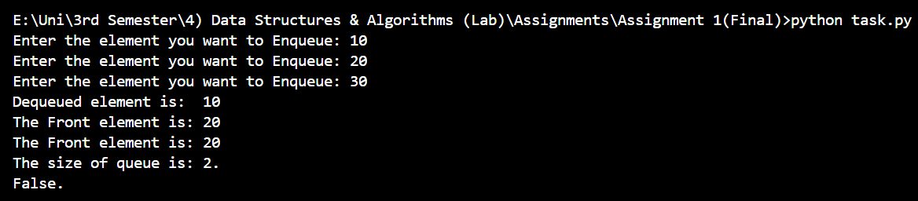

**Task # 3:**

**Objective**: Implement the following sorting algorithms and compare their performance:

1. **Bubble Sort**
2. **Selection Sort**
3. **Insertion Sort**

For each sorting algorithm, write a function that takes a list of integers as input and returns a sorted list. Implement a performance comparison by sorting a list of 1000 random integers and measuring the execution time for each algorithm.

**Code:**

import random

import time

def bubble(list1):

    # print(f"Before Sort: {list1}.")

    for i in range(len(list1)-1):

        for j in range(len(list1)-1-i):

            if list1[j]>list1[j+1]:

                list1[j],list1[j+1]=list1[j+1],list1[j]

    # print(f"After Sort: {list1}.")

# bubble([64, 34, 25, 12, 22, 11, 90])

def selection(list2):

    # print(f"Before Sort: {list2}.")

    for i in range(len(list2)-1):

        small=i

        for j in range(i+1,len(list2)):

            if list2[j]<list2[small]:

                small=j

        list2[i],list2[small]=list2[small],list2[i]

    # print(f"After Sort: {list2}.")

# selection([64, 34, 25, 12, 22, 11, 90])

def insertion(list3):

    # print(f"Before Sort: {list3}.")

    for i in range(1,len(list3)):

        key=list3[i]

        j=i-1

        while j>=0 and key<list3[j]:

            list3[j+1]=list3[j]

            j=j-1

        list3[j+1]=key

    # print(f"After Sort: {list3}.")

# insertion([64, 34, 25, 12, 22, 11, 90])

def comparison():

    final_arr=[]

    for i in range(1000):

        final_arr.append(random.randint(1,1000))

    bubble_copy=final_arr.copy()

    start=time.time()

    bubble(bubble_copy)

    end=time.time()

    print(f"Bubble Sort Time: {end-start: .3f} seconds.")

    selection_copy=final_arr.copy()

    start=time.time()

    selection(selection_copy)

    end=time.time()

    print(f"Selection Sort Time: {end-start: .3f} seconds.")

    insertion_copy=final_arr.copy()

    start=time.time()

    insertion(insertion_copy)

    end=time.time()

    print(f"Insertion Sort Time: {end-start: .3f} seconds.")

comparison()

**Output:**



**Task # 4:**

Write a function that inserts an element into a sorted list while maintaining the sorted order. The function should return the updated sorted list.

**Code:**

def sorted_insertion(arr):

    element=int(input("Enter the element to be inserted: "))

    arr.append(element)

    for i in range(len(arr) -1, 0,-1):

        if arr[i]<arr[i-1]:

            arr[i], arr[i-1]=arr[i-1], arr[i]

        else:

            break

    print(arr)

sorted_list = [10,20,30,40,50]

sorted_insertion(sorted_list)

**Output:**

